Template and Instructions for Full Length Paper
(Ar****** 16 PT, Caps for Each Word, BOLD, CENTER)

Name SURNAME¹, Name SURNAME^{2,}*, Name SURNAME¹ (Arial 11 pt, Bold, Center)
¹Institution or Company, City, Country (Arial 11 pt, Center)
²Institution or Company, City, Country
*Corresponding author: e-mail

Abstract: In general, papers should be between 2000 and 4000 words in length. This includes all text, i.e. abstract, references, and all text in tables, acknowledgement and appendices. It is recommended to use this template so that the papers are uniform and thus facilitate the review process. All papers that pass the standard reviewing process, requested by specified Journal (see Conference web page), will have to be formatted according to the rule of that specified Journal. For the authors’ affiliation, include only the information shown in the example above. If more than one author is from one institution/company, do not repeat them. The corresponding author should be marked with an asterisk (no matter the position in the list of authors). The abstract should be informative, giving the scope and emphasizing the main conclusions, results, or significance of the work described. Use short, direct, and complete sentences. It should be as brief as possible and concise. Do not use first person; do not include mathematical expressions; do not refer to the reference, and try to avoid acronyms (Arial 11 pt, Align Justify).

Keywords: 5-8 keywords separated by semicolons (Arial 11 pt, Align Left).

- INTRODUCTION (ARIAL 11 pt, all caps, bold, Align left)
The paper must be written in correct English. Only unpublished material should be submitted, and the corresponding author is responsible for the originality of the paper. The paper is to be written in one-column format on the paper size A4 and be right and left justified, using single spacing (Arial 11 pt). The width of all margins is to be 20 mm. Use this document as a template for MS Word. Otherwise, use this document as an instruction set (Arial 11 pt, Justify).
The paragraph indentation is to be 5 mm. Leave one clear line before a main or secondary heading. Avoid leaving a heading at the bottom of a column, with the subsequent text starting at the top of the next page/column.

- MATERIALS AND METHODS (ARIAL 11 pt, all caps, bold, Align left)
Do not use further subdivision, for instance 2.1.1 is not recommended. It is recommended that footnotes be avoided. Instead, try to integrate the footnote information into the text.

  - Production or Characterization (Arial 11 pt, Bold, Align left)
Use Word program Equations editor to type all equations (size 11 pt). For subscripts and superscripts use letter size 8 pt. Equations should be separated by 6 points from the rest of the text, centred and have to be numbered consecutively from 1 in parentheses on the far right margin of the column, as formula (1):

. (1)

All numbers and brackets in the text and formulas are to be vertical. All variables: a, b, ... , x, y, z, should be set in italic. Indexes should be set according to the pre-given rules, i.e. if index is a number or a letter it should be set vertically. However, if index presents a symbol of a variable it should be set in italic. SI units are strongly encouraged. Avoid combining different units. Units should be typewritten vertically.
Place the figures as close as possible to where they are mentioned in the main text. Figures, numbered consecutively with captions, should be incorporated into the main body of the text. Figures should be centred and separated by one line from the main text by one line. Captions should appear below figures and separated from the main text by one line.

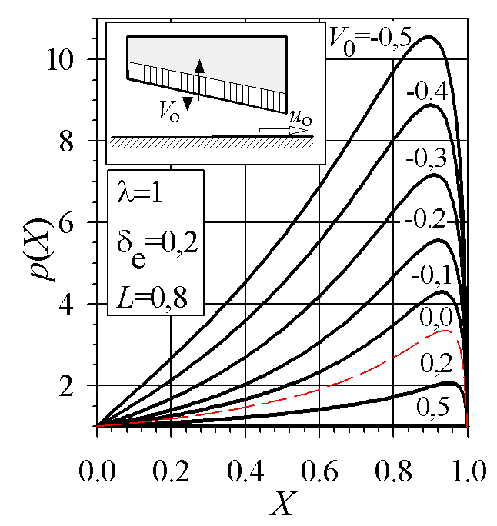
Figure 1. Title (Arial 11 pt, Align Center)

It is important that all numbers and characters appearing in figures are of good quality and well-readable size (≈ 11 pt). Axes labels must be clearly denoted.

- RESULTS and DISCUSSION (ARIAL 11 pt, all caps, bold, Align left)
All tables should be incorporated into the main body of the text and must be centred in the column and numbered consecutively. Place tables as close as possible to where they are mentioned in the main text. Table headings should be placed above the table, as shown in this template. Text and numbers in tables should be typewritten in Arial 11 pt. Tables should be centred and separated by one line from the main text by one line. Captions should appear below tables and separated from the main text by one line.

Table 1. Heading (Arial 11 pt, Align Center)
Element | Chemical composition [%]
Element | SiO₂ | Al₂O₃ | Fe₂O₃ | CaO
Cordierite | 45.52 | 28.10 | 1.23 | 3.70
Talc | 62.20 | 3.11 | 1.25 | 1.07

- CONCLUSIONs (Arıal 11 pt, all caps, bold, Align left)
Although a conclusion may review the main points of the research, do not replicate the abstract as the conclusion. A conclusion might elaborate on the importance of the work or suggest applications and extensions.
References are to be listed in the order of their appearance in the text and numbered. Citation is by the number only which is to be put in square brackets, i.e. [1,2], [3], [4-6] ... etc. Please note that all references listed here must be directly cited in the body of the text. In the reference list (Arial 11 pt, Justify, Hanging 0.75 cm), journal papers [1], books [2], multi-author books [3], theses [4], conference Proceedings [5], standards [6,7] and websites [8] should be cited as shown in this template.

ACKNOWLEDGEMENT (ARIAL 11 PT, ALL CAPS, BOLD, ALIGN LEFT)
If you have some expression of gratitude for assistance or financial support, it should be written after the conclusions.

REFERENCES (ARIAL 11 PT, ALL CAPS, BOLD, ALIGN LEFT)
- H. Czichos, D. Klaffke, E. Santner, M. Woydt: Advances in tribology: the materials point of view, Wear, Vol. 19110, No. 2, pp. 155-161, 1995.
- A.W. Gross: Gas Film Lubrication, John Wiley and Sons, New York, 1992.
- G.W. Stachowiak: Numerical characterization of wear particle morphology, in: I.M. Hutchings (Ed.): New Directions in Tribology, Mechanical Engineering Publications Ltd., Bury St Edmunds, pp. 371-389, 1997.
- J. Stokes: Production of Coated and Free-Standing Engineering Components using the HVOF (High Velocity Oxy-Fuel) Process, PhD thesis, School of Mechanical and Manufacturing Engineering, Dublin City University, Dublin, 2003.
- J.K. Lancaster: Severe metallic wear, in: Proceedings of the Conference on Lubrication and Wear, 01-03.10.1957, London, UK, pp. 1-7 or Paper 7
- ASTM G77-98 Standard Test Method for Ranking Resistance of Materials to Sliding Wear Using Block-on-Ring Wear Test, 1998.
- ISO 14577-1, Metallic Materials – Instrumented Indentation Test for Hardness and Materials Parameters – Part 1: Test Method, 2002.
- Fluid bearing, available at: http://en.wikipedia. org/wiki/Fluid_bearing, accessed: 20.05.2021.

